Project Design Phase
Solution Architecture

Date | 04 October 2026
Team ID | SWTID-2026-5690
Project Name | Implement Client Script & UI Policy (Incident)
Maximum Marks | 4 Marks

Solution Architecture:
Solution architecture is a complex process – with many sub-processes – that bridges the gap between business problems and technology solutions. Its goals are to:
- Find the best tech solution to solve existing business problems.
- Describe the structure, characteristics, behavior, and other aspects of the software to project stakeholders.
- Define features, development phases, and solution requirements.
- Provide specifications according to which the solution is defined, managed, and delivered.

Solution Architecture Diagram:

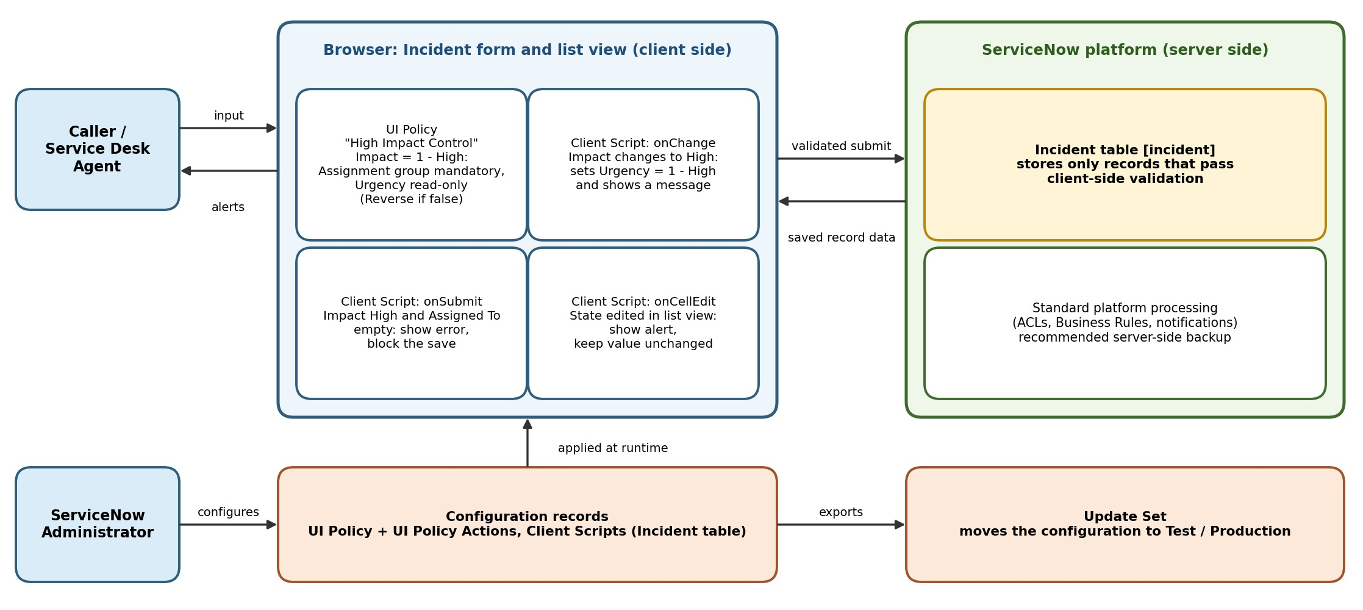
Figure 1: Architecture and data flow of the Client Script and UI Policy solution on the ServiceNow Incident form
Components and data flow:
1. Users: Callers and service desk agents enter or edit Incident data in the browser; messages and alerts are returned immediately.
2. Client-side layer: The UI Policy "High Impact Control" makes Assignment group mandatory and Urgency read-only when Impact is 1 - High, and reverses these effects when the condition is no longer true. The onChange script sets Urgency to 1 - High; the onSubmit script blocks the save when Impact is High and Assigned To is empty; the onCellEdit script blocks State edits in the list view.
3. Server-side layer: Only records that pass client-side validation are submitted to the Incident table; ACLs and Business Rules remain the server-side safeguard.
4. Configuration and deployment: The administrator creates the UI Policy and Client Scripts and moves them to other instances with an Update Set.
Reference: https://docs.servicenow.com

